BRIDGE AI SMART MUSHROOM SYSTEM
PROPOSED ROOOM STRUCTURE AND COMPONENTS
Room structure Dimensions
The room structure dimensions proposed are 3.5 m in length, 3m in width and 2.5 m height.
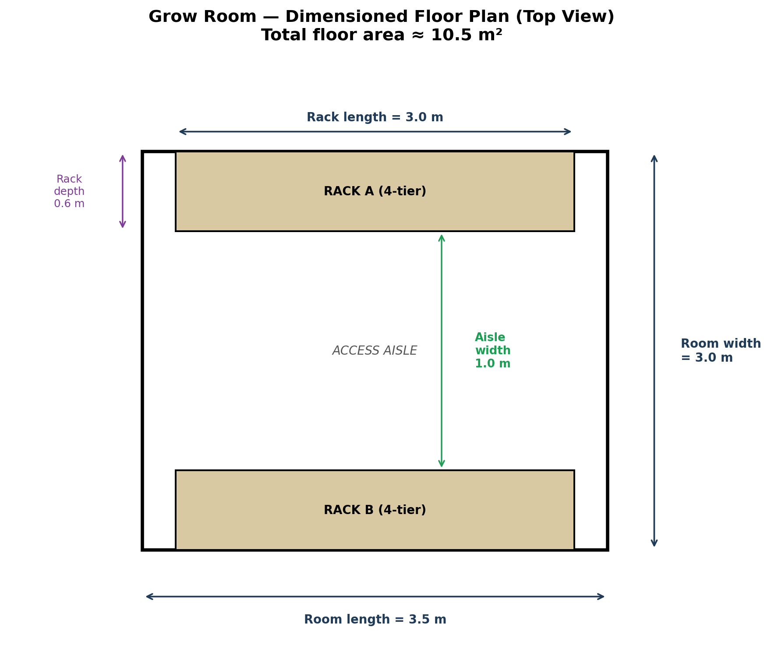

Component selection and placement.

HARDWARE COMPONENTS REQUIRED

1. SENSORS
A) TEMPETAURE AND HUMIDITY
DHT 22 SENSOR (3)
B) CO2 sensor
MH-Z19B / SCD 30 (2)
C) Water level SENSOR (1)
D) LIGHT SENSOR/LDR/ BH 1750 (1)

2. CAMERA MODULE/CCTV (1)
3. MICROCONTROLLERS
ESP 32 (1)
Raspberry Pi for edge computing. (1)
GSM module (1)
4. ACTUATORS
A) Humidity actuator
Fogger/ Ultrasonic Mist Maker (4)
B) CO2 Actuator
Exhaust/ Ventilation Fan 1(1)
C) Temperature Actuators
Heating element and Cooling Fan (2)
D) Substrate Actuator
Pump for water Regulation (1)
E) Light Actuator (LEDs)
5. BUZZER (1)
6. JUMPER WIRES/BREADBOARS/RESISTORS (220 OHMS AND 1k OHMS)/capacitors/inductors/SWITCHES/PCD BOARD/ETCHANT (HCL)/FEMALE AND MALE HEADER PINS/SOLDIERING WIRE AND GUN/ GLUE GUN
7. RELAY (1)
8.POWER SOURCE: SOLAR PANEL/LITHIUM BATTERY/ BUCK and BOOST CONVERTORS/VOLTAGE REGULATOR.

SENSORS
- DHT 22(Temperature and humidity sensor):
- One DHT22 sensor works effectively within a space of approximately 28–56 m³.
- Our room has a volume which falls within this range.
- However, we decided to use 3 DHT22 sensors to improve measurement accuracy and provide redundancy in case one sensor fails.
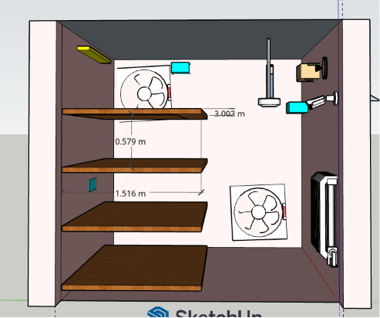
Figure 1: DHT sensors are represented by the blue cubes
- MH-z19B / SCD 30 (CO2 sensors):
- MH-z19B has a measurement range of 0–5000 ppm and is cheaper than SCD 30
- SCD 30 has a measurement range of 0–40,000 ppm and higher accuracy.
- We preferred using SCD 30 as the CO2 sensor (WHY: During the incubation stage our CO₂ levels are between 10,000ppm-20,000 ppm)
- Therefore, we require one SCD30 sensor.
- Positioning: Middle of the wall opposite the shelf racks.
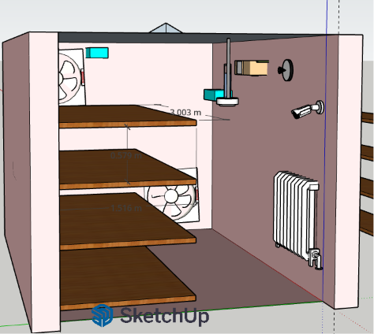
Figure 2: SCD 30 is represented by the beige/ brown box on the right wall
- BH 1750 (Light Sensor):
- Has a measurement range of 1–65,535 lux.
- Only one BH1750 sensor is required.
- Positioning: Upper section of the wall opposite the shelf racks.

Figure 3: BH 1750 represented by the circular object with something poking out on the right wall

ACTUATORS
- Exhaust fan
- One exhaust fan with over 100CFM
- Mushrooms need an active fresh air exchange rate of 4 to 8 full air changes per hour (ACH)
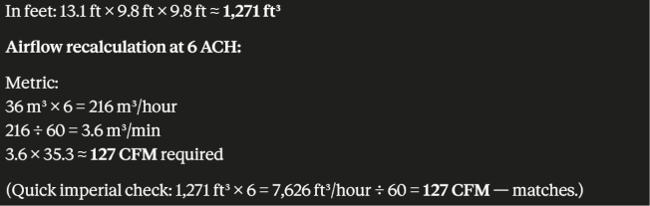
- Positioning: Back wall top left corner

Figure 4: Exhaust fan is represented by the fan at the top back wall

- Humidifier-Ultrasonic fogger
- For a grow room the output range of the humidifier should be between 500-3000ml/hour
- This can be achieved using a 3-head or 4-head ultrasonic fogger. (Note: Because it outputs 900 to 1,500 mL of water per hour, running it continuously will quickly turn your room into a dense, foggy swamp.)
- From figure 4, the humidifier is positioned on the ceiling

- Cooling fan
- Heater
- Positioning: Bottom of the wall opposite the shelves (WHY?: Cold air is denser and sinks placing the heater low means it's warming the coldest air first heat naturally rises and distributes upward through the room on its own)
- LED strips
- Because of the wide stacked shelf placing an LED at the ceiling may prevent light from reaching the lower shelves
- Solution: Install waterproof IP65 or IP67 LED strips along the underside of each shelf.
- 2W LED strips is sufficient.
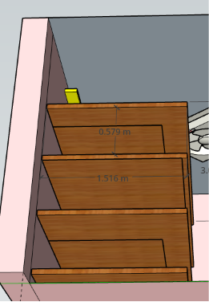
Figure 5: LED strips are represented by the line underneath the shelf plus the yellow box above the top shelf

